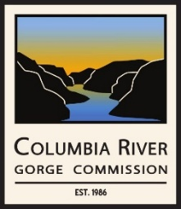 | Columbia River Gorge Commission  Communications Committee Meeting  June 18, 2026 – 9:00 a.m. to 10:00 a.m.  via Zoom Meeting

AGENDA

- Roll call
- Review and approval of the 5/19/2026 meeting summary
- Review draft Communications Best Practices guidance document
- Review Avarna report findings regarding outreach and communications
- Discuss addressing inquiries about Cascade Renewal Transmission and Pushpum energy storage facility
- Outreach strategy to legislators in fall 2026 to prepare for CRGC 2027-2029 budget submission and legislative session
- Other business
- Public comment

You are invited to a Zoom meeting:

June 18, 2026, at 9:00 AM Pacific Time
Use the following link to join the meeting: https://us02web.zoom.us/j/89606571434?pwd=dEPonr1FNZfotyoomicoaCK6AV2zwb.1

Dial by your location
• +1 971 247 1195 US (Portland)
• +1 253 215 8782 US (Tacoma)

Meeting ID: 896 0657 1434
Passcode: 237722

