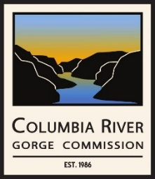 | Columbia River Gorge Commission  Executive Committee Meeting  November 25, 2025 – 8:30 a.m. to 9:00 a.m.  via Zoom Webinar

AGENDA

- Roll Call
- Finalize December 16, 2025, Columbia River Gorge Commission Meeting Agenda
- Other Business
- Public Comment - Public comment is welcome on the draft Agenda or for general announcements. Public comment on Commission business should be reserved for regular Commission meetings.

You are invited to a Zoom webinar:
November 25, 2025, at 8:30 AM Pacific Time (US & Canada)
Registration is required for this meeting. Use the following link to register for the meeting:
https://us02web.zoom.us/webinar/register/WN_ryrCzmdMRuSyc2iNDyPIrg

Dial by your location
• +1 971 247 1195 US (Portland)
• +1 253 215 8782 US (Tacoma)

Webinar ID: 885 1087 8815

