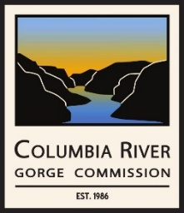 | Columbia River Gorge Commission  Rules Committee Meeting  Friday, February 21, 2025 – 1:00 p.m. to 2:00 p.m.  via Zoom Meeting

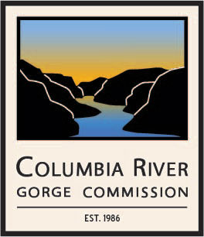

Columbia River Gorge Commission
Rules Committee Meeting
February 21, 2025 – 1:00 p.m. to 2:00 p.m.
You are invited to a Zoom meeting:
February 21, 2025, at 1:00 PM Pacific Time (US and Canada)
The meeting is to confirm the scope of the committee; discuss the committee’s manner of discussing draft rules to divisions 11, 12, 14, and 16 of the Gorge Commission’s rules; and discuss how to review comments from the states’ attorneys general, which were provided to the Commission as attorney-client privileged.

Use the following link to join the meeting:
https://us02web.zoom.us/j/87037921073?pwd=lAXD7Pe8z97SbXKgdOl9wtZABTbydO.1

Meeting ID: 870 3792 1073
Passcode: 173036
---
One tap mobile
+19712471195,,87037921073#,,,,*173036# US (Portland)
+12532158782,,87037921073#,,,,*173036# US (Tacoma)
---
Dial by your location
• +1 971 247 1195 US (Portland)
• +1 253 215 8782 US (Tacoma)

Meeting ID: 870 3792 1073
Passcode: 173036

