Application Checklist
The Gorge Commission requires the following information before it can start to review your proposal:
• Application form completed and signed
• Site plan
• Key viewing areas checklist, elevation drawings, and landscape details, if required
• Names and addresses of adjacent property owners, if required
• Any additional information as required
How the Gorge Commission Reviews Development Proposals
The Gorge Commission reviews land use application using the requirements in the land use ordinance. There are two processes: Expedited Review and Review Use. The type of process depends on your proposal. Both processes involve the following steps:
• Completeness review
• Notice and comment period
• Gather and analyze information
• Prepare and issue decision
The Gorge Commission recommends scheduling a pre-application meeting to discuss your project with a planner before submitting your application for review. A pre-application meeting with a Gorge Commission planner can help you determine how your proposal will be reviewed and answer questions about what materials may be necessary for a complete application. You may submit your application by email, mail or in person.
Completing the Land Use Application
Some projects may require additional information about the project and the surrounding area. A planner can help clarify whether your project will require additional information. Incomplete applications cannot be accepted for review. A planner will contact you if your application is not complete and inform you what additional information must be submitted to complete the application.
The property owner (if different from the applicant) and persons or entities that hold an easement or other partial interest that might be affected by the proposal must sign the application to acknowledge they are aware of and consent to the application. You may get signatures on copies of the application forms, but the forms must all be the same.
Please contact the Columbia River Gorge Commission’s office if you need assistance or have any questions. Please call 509-493-3323 or contact us via our website at www.gorgecommission.org.

Applicant(s)
Mailing Address:
Phone:
Email
Property Owner(s)
Mailing Address:
Phone:
Email
Street Address
of Parcel
Township, Range,
Section, Qtr. Section
Tax Lot Number(s)
Parcel Size
Summary of
Proposal
Existing Use
of Parcel
Existing Buildings and Structures: Please provide the following information for each building and structure on the parcel.
Building or Structure  (do not include fences or roads) | Size  (square feet) | Height  (measure from lowest point) | Length and Width | Year Built  (if known)
Detailed Project Description: Please describe all proposed development and use of the development, including size, height, exterior colors, construction materials of proposed structures (including access roads), areas of ground disturbance, landscaping details, and structures that you propose to remove. Please describe all aspects of your project in this description or the public notice and final decision may not include an element of your development, which could require a new notice and decision. You may attach additional pages if necessary.

Adjacent Uses: Please briefly describe the use of parcels that adjoin your parcel, including use, number and types of buildings, approximately distance from the property lines, and access roads.
Signatures and Authorization to Access the Property: The property owner and holders of easements and partial interests indicate that they are aware that this application is being made on the subject property and the property owner authorizes the Gorge Commission and the Commission’s designees reasonable access to the site to evaluate the application. Property owners and easement or partial interest holders may sign copies of this signature page.
Applicant(s) signature: | Date
Property owner(s) signature: | Date
Easement and Partial Interest(s) signature: | Date
Site Plan

You must provide a site plan drawn in black ink at a scale of 1 inch equals 200 feet (1:2400) or at a scale providing greater detail. You may use the attached grid or provide a separate site plan.
If the parcel is very large, you may show only the portion of the parcel affected by the proposed use. Be sure, however, to show enough of the parcel or some adjacent features, such as roads, so the planners can orient themselves on your map, and clearly identify the location of your proposal. A small vicinity map showing the subject parcel and surrounding parcels may help.
At a minimum, you must show the following features on your site plan. Other site plan information may be required depending on the type or location of development that you are proposing.
• North arrow
• Map scale
• Boundaries, dimensions, and size of the subject parcel
• Significant terrain features or landforms (e.g., cliffs, rock faces, slopes, stands of trees)
• Groupings and species of trees or other vegetation on the parcel
• Location and species of vegetation that would be removed or planted
• Bodies of water and watercourses, including intermittent and ephemeral streams
• Location and width of existing and proposed roads, driveways, and trails
• Location, dimensions, height, and size (in square feet) of existing and proposed structures
• Location of existing and proposed services including wells or other water supplies, sewage disposal systems, power and telephone poles and lines, and outdoor lighting
• Location and depth of all proposed grading and ditching

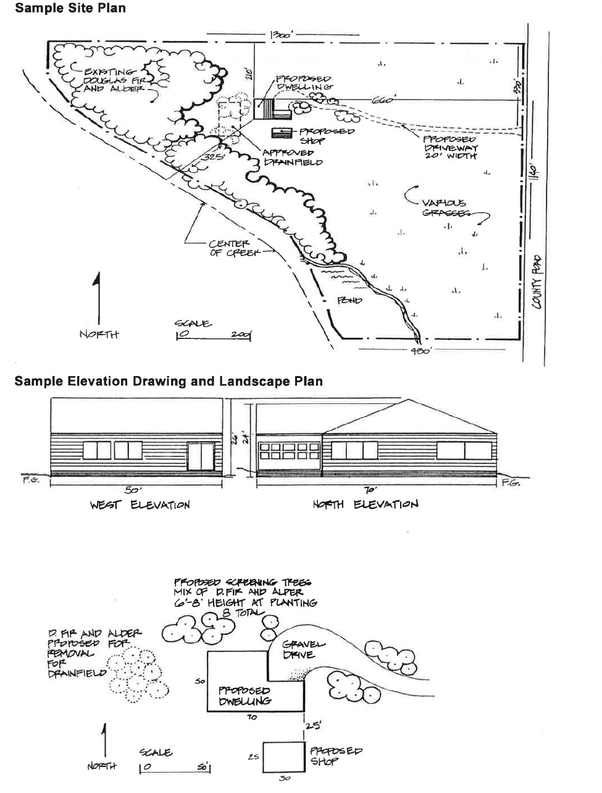
Site Plan

(Indicate scale: each grid equals ____ x ____ feet)
. . . . . . . . . . . . . . . . . . . . . . . . . . . .

. . . . . . . . . . . . . . . . . . . . . . . . . . . .

. . . . . . . . . . . . . . . . . . . . . . . . . . . .

. . . . . . . . . . . . . . . . . . . . . . . . . . . .

. . . . . . . . . . . . . . . . . . . . . . . . . . . .

. . . . . . . . . . . . . . . . . . . . . . . . . . . .

. . . . . . . . . . . . . . . . . . . . . . . . . . . .

. . . . . . . . . . . . . . . . . . . . . . . . . . . .

. . . . . . . . . . . . . . . . . . . . . . . . . . . .

. . . . . . . . . . . . . . . . . . . . . . . . . . . .

. . . . . . . . . . . . . . . . . . . . . . . . . . . .

. . . . . . . . . . . . . . . . . . . . . . . . . . . .

. . . . . . . . . . . . . . . . . . . . . . . . . . . .

. . . . . . . . . . . . . . . . . . . . . . . . . . . .

. . . . . . . . . . . . . . . . . . . . . . . . . . . .

. . . . . . . . . . . . . . . . . . . . . . . . . . . .

. . . . . . . . . . . . . . . . . . . . . . . . . . . .

. . . . . . . . . . . . . . . . . . . . . . . . . . . .

. . . . . . . . . . . . . . . . . . . . . . . . . . . .

. . . . . . . . . . . . . . . . . . . . . . . . . . . .

. . . . . . . . . . . . . . . . . . . . . . . . . . . .

. . . . . . . . . . . . . . . . . . . . . . . . . . . .

. . . . . . . . . . . . . . . . . . . . . . . . . . . .

. . . . . . . . . . . . . . . . . . . . . . . . . . . .

. . . . . . . . . . . . . . . . . . . . . . . . . . . .

. . . . . . . . . . . . . . . . . . . . . . . . . . . .

. . . . . . . . . . . . . . . . . . . . . . . . . . . .

. . . . . . . . . . . . . . . . . . . . . . . . . . . .

. . . . . . . . . . . . . . . . . . . . . . . . . . . .

. . . . . . . . . . . . . . . . . . . . . . . . . . . .

. . . . . . . . . . . . . . . . . . . . . . . . . . . .

. . . . . . . . . . . . . . . . . . . . . . . . . . . .

. . . . . . . . . . . . . . . . . . . . . . . . . . . .

. . . . . . . . . . . . . . . . . . . . . . . . . . . .
Key Viewing Areas

Key viewing areas are important public viewpoints and areas that afford opportunities to view the Gorge scenery (350-082-0070(108)).
Please check which of the following key viewing areas that can be seen from your proposed development site, even if the building site is blocked by trees. You do not need to check key viewing areas that are blocked by topography.
□ Historic Columbia River Highway
□ Old Highway 8
□ Highway I-84
□ Washington State Route 14
□ Washington State Route 141
□ Washington State Route 142
□ Panorama Point Park
□ Columbia River
□ Rowena Plateau and Nature Conservancy Viewpoint
□ Cook-Underwood Road
If your project could be visible from one or more key viewing areas, then you must submit elevation drawings and landscaping details.
Elevation drawings must show the sides of proposed buildings that could be visible from key viewing areas, must be drawn to scale, and must include the following:
• Geometrical exterior of the length and width of structures as seen from a horizontal view.
• Sizes and dimensions of windows, doors, and covered openings;
• Natural grade
• Finished grade
Landscape details must show how you propose to screen your project from key viewing areas and must include the following:
• Location of plants used
• Number of plants
• Size of plants
• Type of plants
• Irrigation provisions or other measures to ensure the survival of landscaping planted for screening purposes
• Location of existing and proposed topographical features, such as berms, that would screen your project.
Elevations and Site Plan Details

(Indicate scale: each grid equals ____ x ____ feet)
. . . . . . . . . . . . . . . . . . . . . . . . . . . .

. . . . . . . . . . . . . . . . . . . . . . . . . . . .

. . . . . . . . . . . . . . . . . . . . . . . . . . . .

. . . . . . . . . . . . . . . . . . . . . . . . . . . .

. . . . . . . . . . . . . . . . . . . . . . . . . . . .

. . . . . . . . . . . . . . . . . . . . . . . . . . . .

. . . . . . . . . . . . . . . . . . . . . . . . . . . .

. . . . . . . . . . . . . . . . . . . . . . . . . . . .

. . . . . . . . . . . . . . . . . . . . . . . . . . . .

. . . . . . . . . . . . . . . . . . . . . . . . . . . .

. . . . . . . . . . . . . . . . . . . . . . . . . . . .

. . . . . . . . . . . . . . . . . . . . . . . . . . . .

. . . . . . . . . . . . . . . . . . . . . . . . . . . .

. . . . . . . . . . . . . . . . . . . . . . . . . . . .

. . . . . . . . . . . . . . . . . . . . . . . . . . . .

. . . . . . . . . . . . . . . . . . . . . . . . . . . .

. . . . . . . . . . . . . . . . . . . . . . . . . . . .

. . . . . . . . . . . . . . . . . . . . . . . . . . . .

. . . . . . . . . . . . . . . . . . . . . . . . . . . .

. . . . . . . . . . . . . . . . . . . . . . . . . . . .

. . . . . . . . . . . . . . . . . . . . . . . . . . . .

. . . . . . . . . . . . . . . . . . . . . . . . . . . .

. . . . . . . . . . . . . . . . . . . . . . . . . . . .

. . . . . . . . . . . . . . . . . . . . . . . . . . . .

. . . . . . . . . . . . . . . . . . . . . . . . . . . .

. . . . . . . . . . . . . . . . . . . . . . . . . . . .

. . . . . . . . . . . . . . . . . . . . . . . . . . . .

. . . . . . . . . . . . . . . . . . . . . . . . . . . .

. . . . . . . . . . . . . . . . . . . . . . . . . . . .

. . . . . . . . . . . . . . . . . . . . . . . . . . . .

. . . . . . . . . . . . . . . . . . . . . . . . . . . .

. . . . . . . . . . . . . . . . . . . . . . . . . . . .

. . . . . . . . . . . . . . . . . . . . . . . . . . . .

. . . . . . . . . . . . . . . . . . . . . . . . . . . .

Adjacent Property Owners

You must submit names and address of adjacent property owners within a specified distance (200 feet or 500 feet (350-082-0110)) of the perimeter of your parcel. The following list specifies the distance within which property owners must be notified of your proposal. You only need to provide the names and address (along with the parcel number); the Commission will send the notice.
Klickitat County's Interactive Mapping program can assist in obtaining this property owner information. The mapping program is found on Klickitat County's website at http://www.klickitatcounty.org/524/Interactive-Mapping-Program. Use the search function of the mapping tool to find your parcel and the adjacent property owners. Clicking on the parcel will display the owner’s name, mailing address, and tax lot number. You may use the form on the next page to record the names and addresses or you may submit forms which the county may provide you.
Landowners within 200 feet
• All applications, except those listed below
Landowners within 500 feet
• Single family dwellings in the GMA Residential Land Use Designation adjacent to GMA Agriculture or Forest Land Use Designations
• Commercial events and special uses in historic buildings adjacent to GMA Agriculture or Forest Land Use Designations
• Non-farm single family dwellings in the GMA Large-Scale Agriculture Land Use Designation
• Within GMA Forest Land Use Designations: utility facilities, railroads, home occupations, fruit & produce stands, wineries, wine sales/tasting rooms, ag. product processing and packaging, mineral resources, geothermal resources, aquaculture, boarding of horses, temporary asphalt/batch plants, expansion of non-profit camps/retreats/conference centers, bed and breakfasts, non-profit learning/research facilities, fish processing operations, road spoils disposal sites
Adjacent Property Owners
Township, Range, Section,  Tax Lot Number | Name and Address (and e-mail if possible)
Additional Information

If you are proposing one of the project types listed below, then you must submit additional information with your application. Please consult with a Gorge Commission planner about what additional information you must submit.
Grading Plans
The following projects require a grading plan. Your grading plan must be prepared by a qualified professional, such as an architect, landscape architect, or engineer. A Gorge Commission planner can help your professional with the requirements for a grading plan.
In the General Management Area:
• Applications for structural development involving more than 100 total cubic yards of grading (the total of all material moved, removed, or added to the project site) with slopes of more than 10%
• Applications for structural development involving more than 200 total cubic yards of grading (the total of all material moved, removed, or added to the project site) where the building site is visible from one or more Key Viewing Areas
In the Special Management Area:
• Applications for structural development involving more than 100 total cubic yards of grading (the total of all material moved, removed, or added to the project site) with slopes of more than 10% (except trails)
Specific Land Uses
If your project is listed below, you will also need to submit additional information. A Gorge Commission planner will help you identify the additional information required.
In the General Management Area:
• Agricultural buildings (350-082-0380)
• Projects within 1000 feet of water resources, rare wildlife sites or rare plant sites
• Single-family dwellings on lands designated Small Woodland (350-082-0270(3)(a))
• Single-family dwellings in conjunction with agricultural use (350-082-0240(3)(h))
• Single-family dwellings on Large-Scale Agriculture not in conjunction with agricultural use (350-082-0240(3)(h) and (p))
• Wine or cider sales and tasting rooms (350-082-0310(4)(L))
• Temporary hardship dwelling (350-082-0390)
• New communications and utility facilities on lands visible from key viewing areas (350-082-0600(2)(n) and (o))
• New livestock grazing; new fences, livestock watering facilities, and corrals; or soil, water, and vegetation conservation activities on lands designated Agriculture-Special (350-082-0130(1)(b))
• Expansion of Existing Quarries and Exploration, Development, and Production of Mineral Resources (350-082-0500)
• Uses located in or providing recreational access to the Columbia River or its tributaries (350-082-0700(5)(f) and (g))
In the Special Management Areas:
• Single-family dwellings on lands designated Forest, Agriculture or Public Recreation
• Agricultural buildings and agricultural labor housing
• Clearing trees for new agricultural use
• Any new use or development on lands designated Open Space
In the General Management Area and Special Management Areas:
• Signs (350-082-0052)
• Home Occupations (350-082-0420)
• Overnight Accommodations (350-082-0430)
• Small-Scale Fishing Support and Fish Processing Operations (350-082-0450)
• Resource Enhancement Projects (350-082-0460)
• Disposal Sites for Spoil Materials from Public Road Maintenance (350-082-0470)
• Commercial Events (350-082-0480)
• Recreation Resorts (350-082-0490)
• Buffer Zones/Buildings in Agriculture (350-082-0580)
Projects Requiring Cultural Resources Reconnaissance Surveys
and Historic Surveys (350-082-0620(1) and (2))
• Residential development of two or more dwellings
• Recreation facilities
• Commercial development
• Public transportation facilities
• Electric facilities, lines, equipment, and appurtenances that are 33 kilovolts or greater
• Communications, water and sewer, and natural gas transmission lines, pipes, equipment, and appurtenances
Projects Requiring Sensitive Plant and Wildlife Surveys
(350-082-0650(2) and 350-082-0660(2))
• Land divisions that create four or more parcels
• Recreation facilities that contain parking areas for 10 cars, overnight camping facilities, boat ramps, and visitor information and environmental education facilities
• Public transportation facilities that are outside improved rights-of-way
• Electric facilities, lines, equipment, and appurtenances that are 33 kilovolts or greater
• Communication, water and sewer, and natural gas transmission lines, pipes, equipment, and appurtenances
Parcel Documentation in Klickitat County

The National Scenic Area definition of parcel (350-082-0070(133)) recognizes units of land as separate parcels when those units of land complied with zoning and subdivision ordinances in effect at the time of the creation of the National Scenic Area (in 1986). At that time, Klickitat County’s subdivision ordinance defined “Lot” in a manner that consolidated adjacent lots that were in the same ownership. The Gorge Commission may need documentation to determine that your property is a separate and legally created parcel.
The following projects require this documentation:
• All dwellings, including replacement dwellings, agricultural operator’s relative, agricultural labor housing, family hardship mobile homes, and life estates
• Accessory structures
• Land divisions
• Lot-line adjustments
• Other uses, including, wineries, agricultural processing and packaging facilities, recreation, and mining.
Documentation Needed:
Typical documentation may include copies of a short plat or subdivision recorded by the County, prior and current deeds, or a title report.
Short Plat or Subdivision: If your property is a parcel created by a recorded short plat or subdivision, submit a copy of the short plat or subdivision map.
Prior and Current Deeds: If your property was not created by a short plat, then you must submit the following deeds for your parcel and all adjacent parcels:
• The deed showing the ownership on January 1, 1983
• The deed immediately prior to the deed showing the ownership on January 1, 1983
• All deeds from January 1, 1983 to the present. Alternatively, you may submit a title report from a title company that describes this deed history (be sure to have the title company include copies of the deeds in the title report)
You may obtain a copy of deeds or a short plat map from the Klickitat County Recorder's Office. If you need help identifying what documents to submit, a Gorge Commission planner will gladly help you.

